石头 剪刀 布！

In this project you will make Rock, Paper, Scissors in Scratch.

To have your move, you’ll take a photo of your hand.

But first, you’ll need to train the computer to look at your photos and recognise the different hand shapes of rock, paper, and scissors.

在这个项目中我们将使用Scratch制作石头剪刀布的游戏

为了你的行动，你要给你的手拍一张照片。

但是首先,你需要训练计算机观察你的照片,识别代表石头,布和剪刀手的不同形状

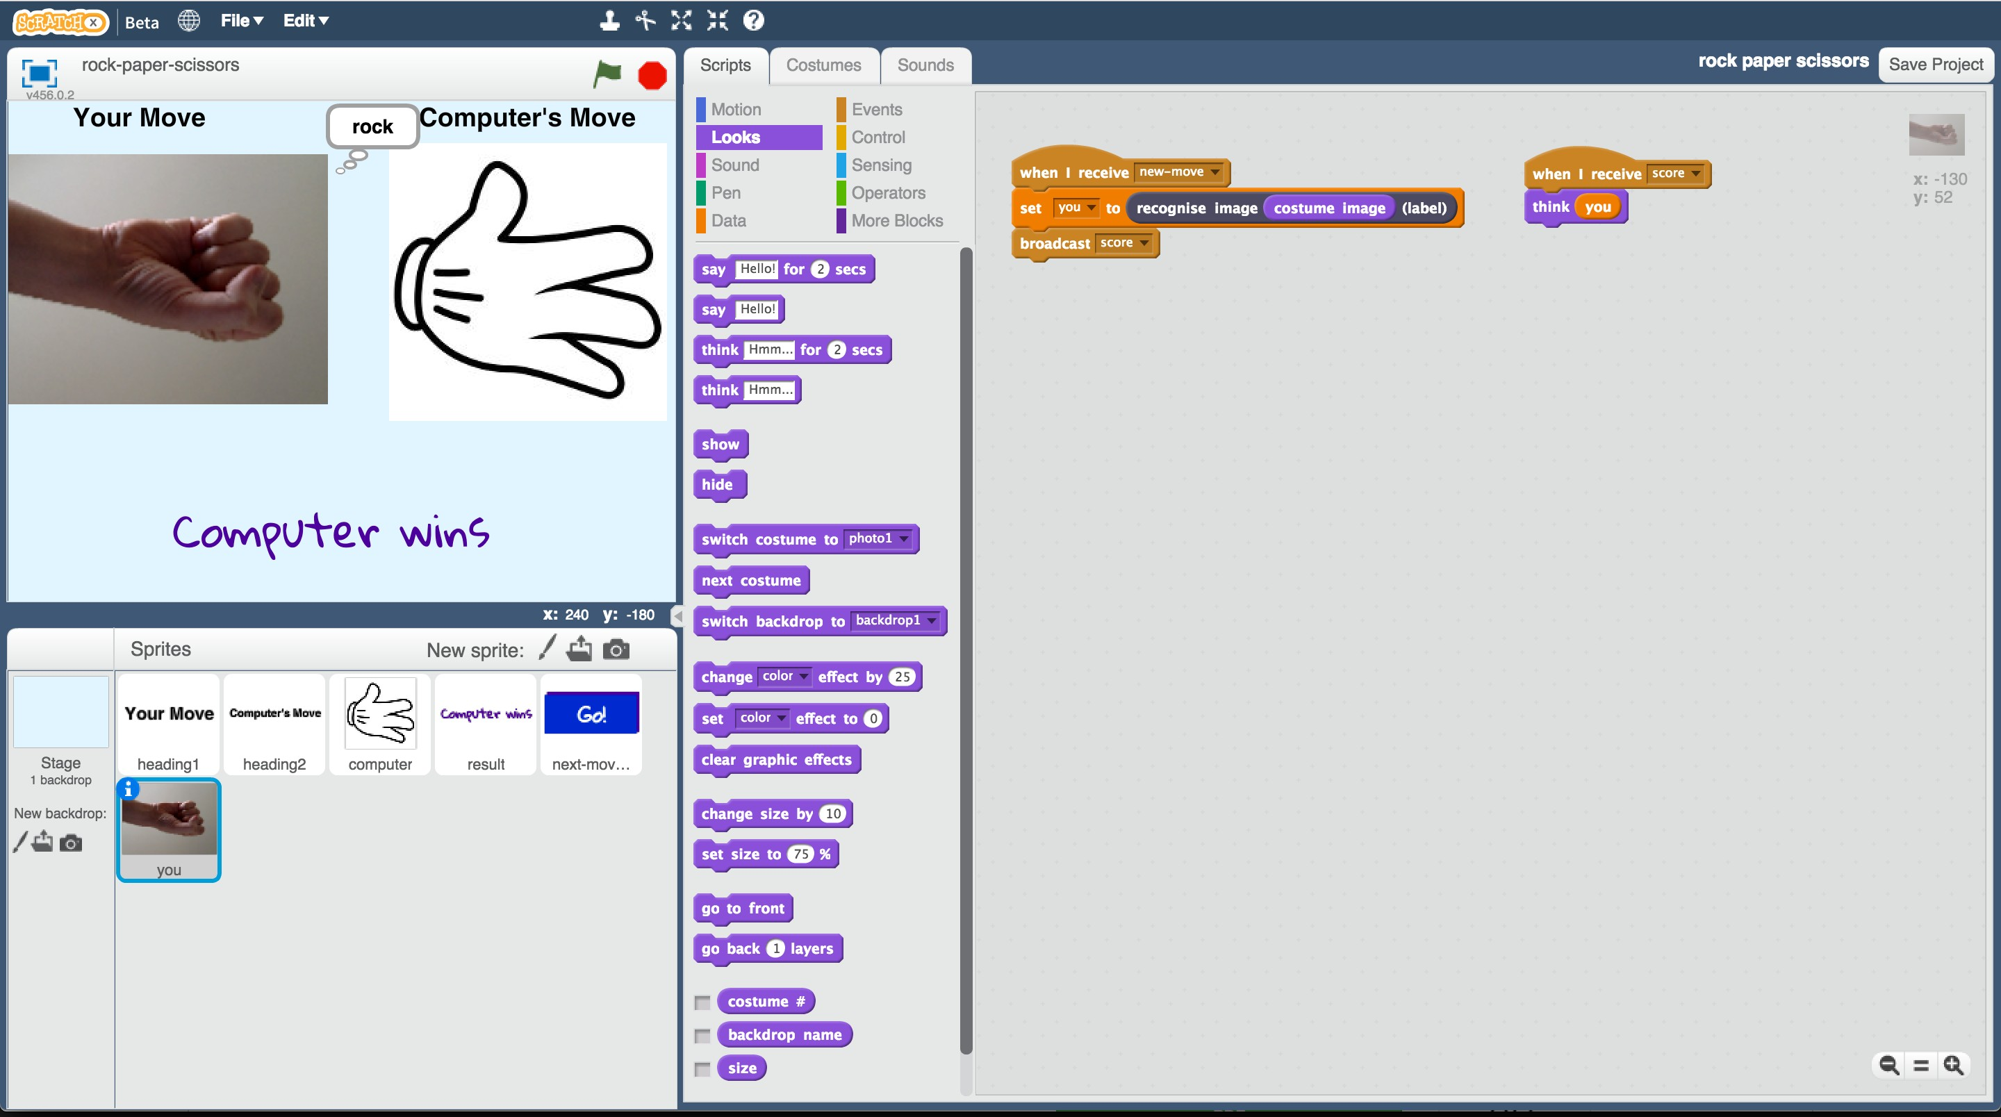

This project worksheet is licensed under a Creative Commons Attribution Non-Commercial Share-Alike License <http://creativecommons.org/licenses/by-nc-sa/4.0/>



**This activity will include you taking pictures of your hand & uploading them.**

If you’re not happy with that, ask your teacher or group leader for a different activity.

**这个活动要求学生拍自己的手并且上传。**

如果学生不乐意此项活动，请向你的老师或者小组组长参与其他活动

1. Go to https://machinelearningforkids.co.uk/ in a web browser

在浏览器中前往<https://machinelearningforkids.co.uk/>网站

1. Click on “Get started”

点击“Get started”按钮

1. Click on “Log In” and type in your username and password

点击“Log In”按钮并且输入你的用户名以及密码

*If you don’t have a username, ask your teacher or group leader to create*

*one for you.*

*如果你没有用户名，请向你的老师或者小组组长求助创建一个*

*If you can’t remember your username or password, ask your teacher or group leader to reset it for you.*

*如果你没有记住你的用户名或者密码，请向你的老师或者小组组长求助重置。*

1. Click on “Projects” on the top menu bar

点击在顶部菜单栏的“Projects”按钮

1. Click the “+ Add a new project” button.

点击“+Add a new project”按钮

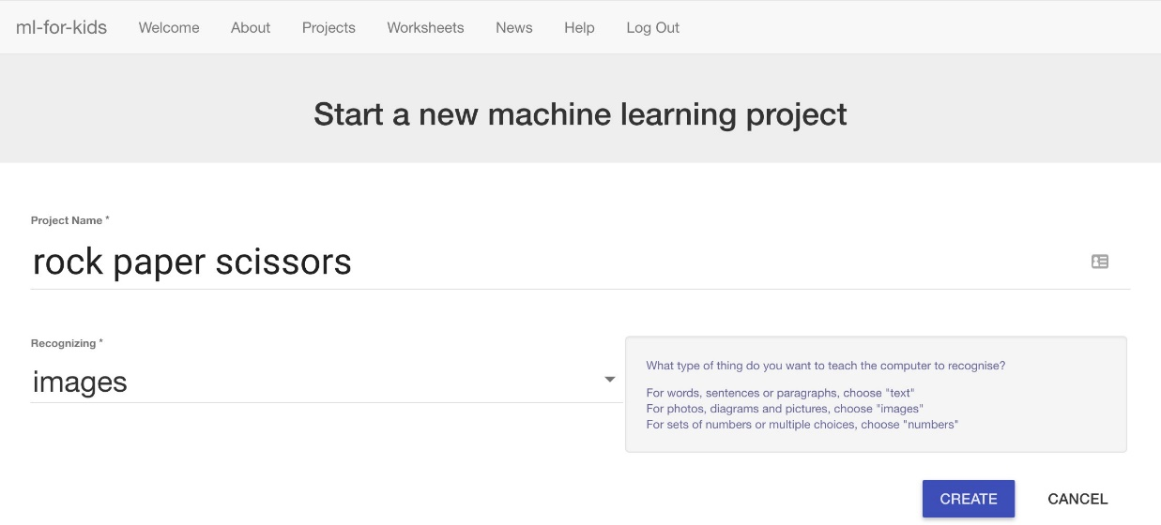

1. Name your project “rock paper scissors” and set it to learn how to recognise “images”.

将你创建的项目命名“石头剪刀布”并设置学习图像识别

1. Click the “Create” button

点击“Create”按钮

1. You should see “rock paper scissors” in the projects list. Click on it.

你应该在项目列表看到“石头剪刀布”并点击他

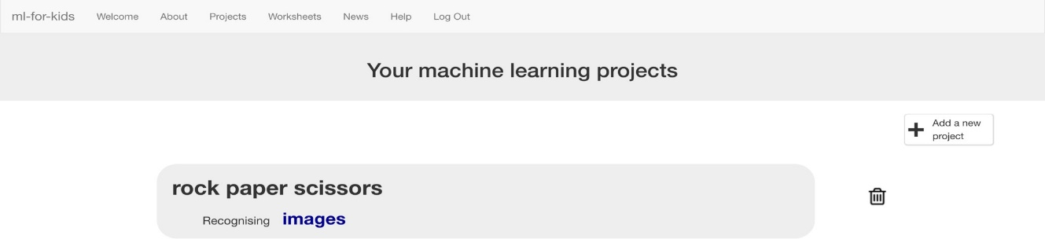

1. Click on “Train”

点击“Train”按钮

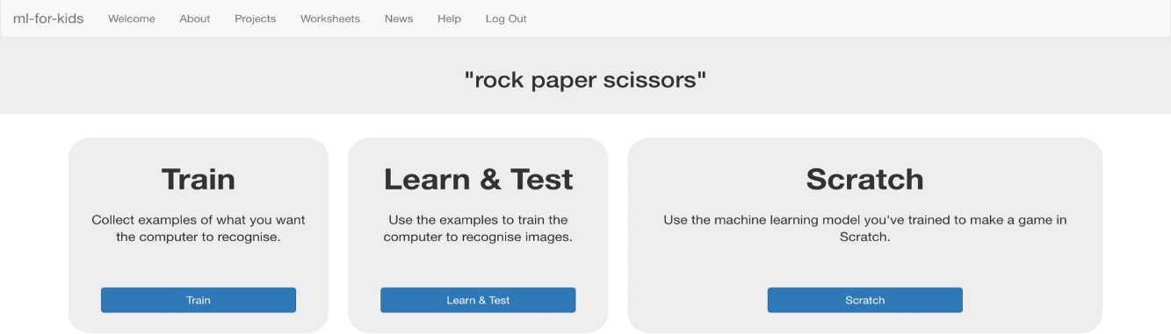

1. Click “+ Add new label” and create a bucket called “rock”.

点击“+Add new label”按钮并且创建一个名叫“石头”分栏

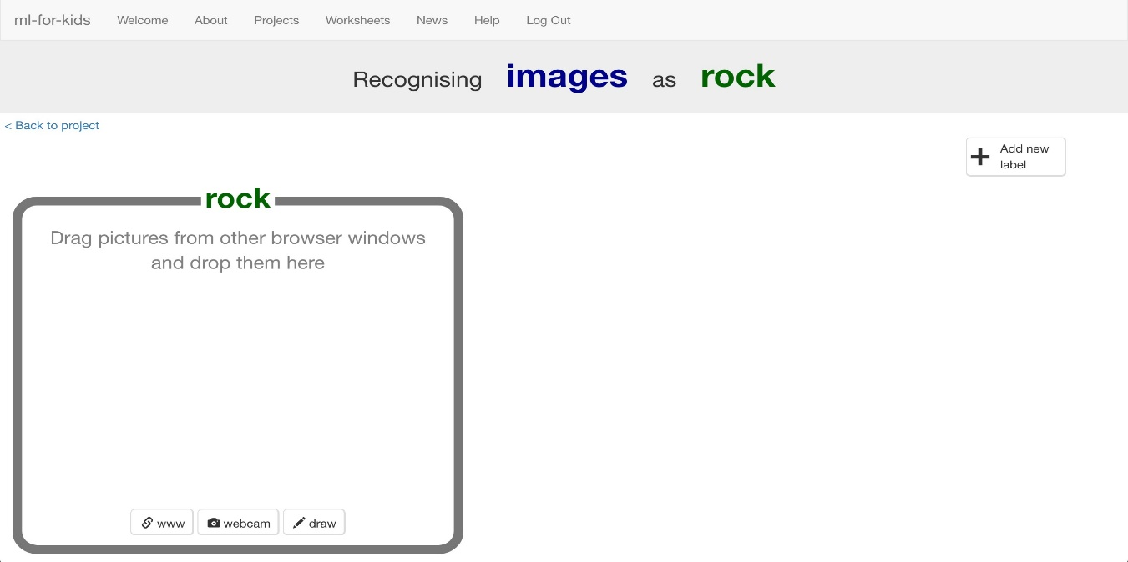

1. Click “webcam”

点击“webcam”按钮

A Preview window shows the current view from your webcam.

将有一个预览窗口显示摄像头的当前内容

*You will need to click “Approve” or “Allow” if your web browser asks permission to use your webcam.*

*你需要点击“Approve”或者“Allow”如果你的浏览器征询使用摄像头的权限*

1. Make your hand into a “rock” shape (fist) in front of the webcam

请在摄像头前将手握拳成“石头”形状

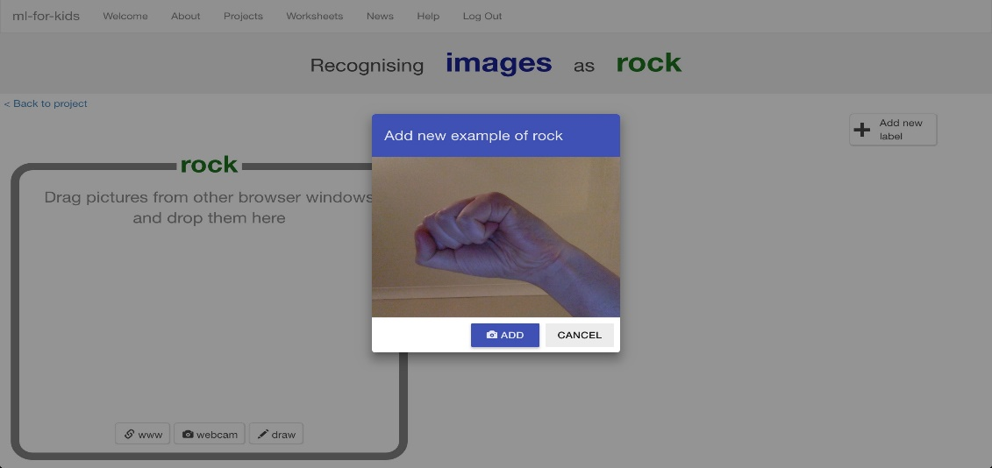

1. When you’re ready, click “ADD” to take a picture

当你做好形状后，点击“ADD”来拍照

*If you’re doing this with a partner, it might be easier for one of you to click*

*on “ADD” while the other makes hand-shapes.*

*如果你正和小伙伴一起参与，可能当一位小朋友做手势时另一位小朋友帮忙点击“ADD”拍照会更方便*

1. Click “**webcam**” again

再次点击“webcam”按钮

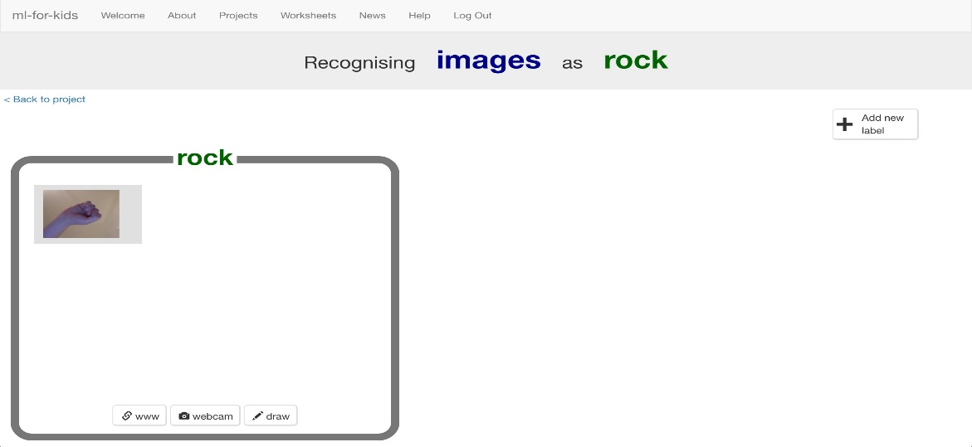

1. Repeat until you’ve got 10 examples of a “rock” shape (fist).

一直重复至拍摄十张“拳头”照片为止

*Try to get a variety of positions and angles.*

*The more variation the computer has to learn from, the better.*

*尝试不同位置、角度得到不同的照片可以使计算机更好地学习如何识别*

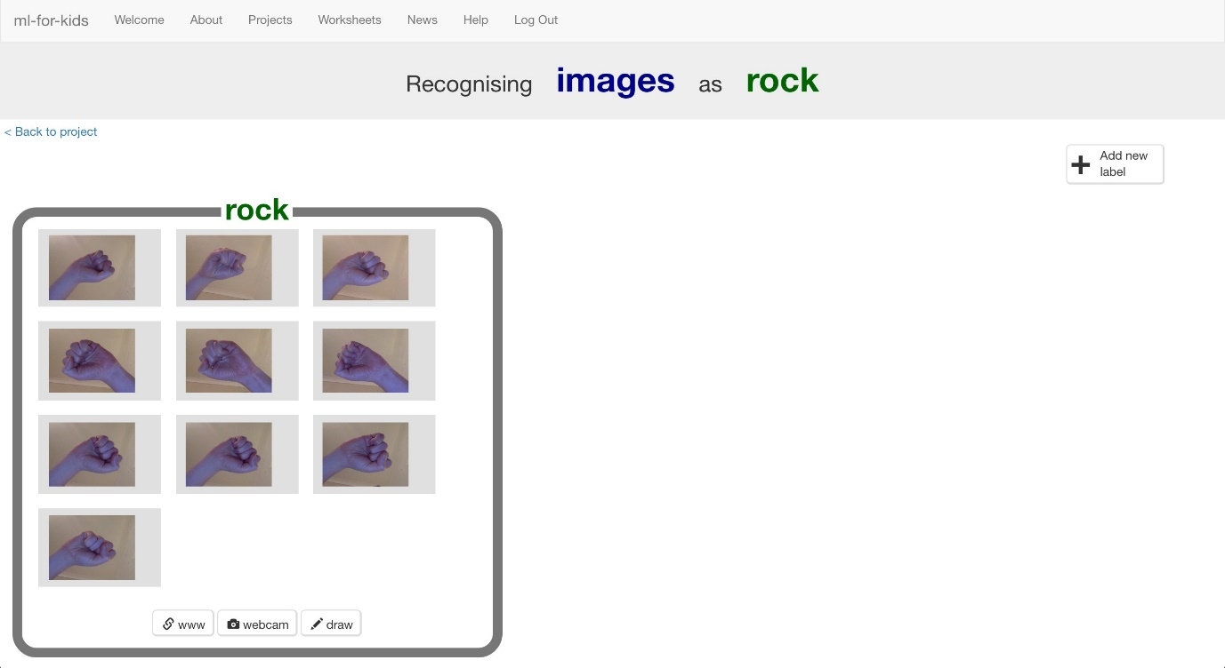

1. Click “**+ Add new label**” and create one called “paper”

点击“+Add new label” 创建并命名成“布”

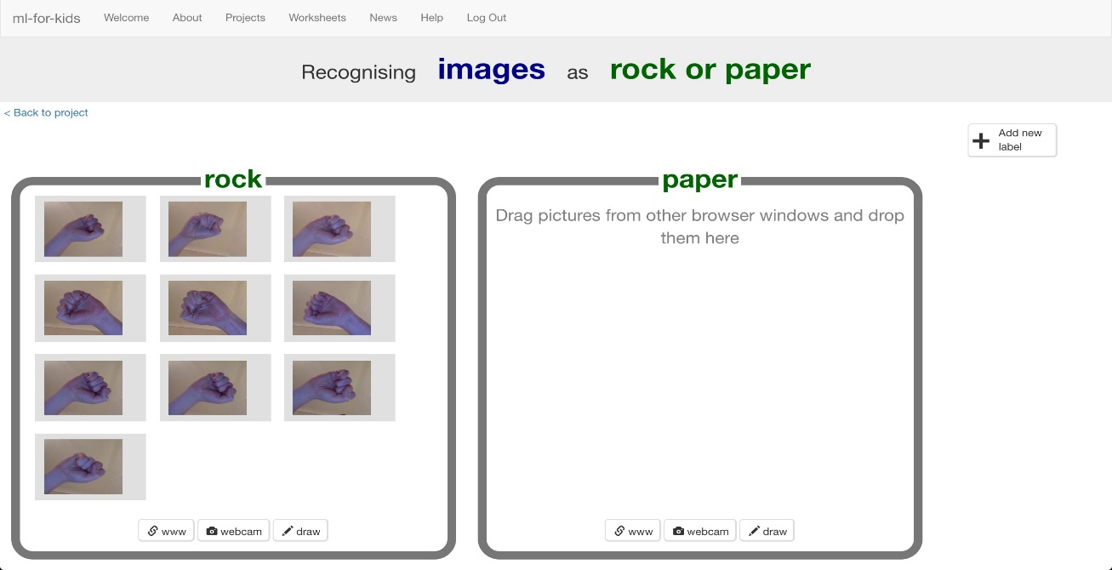

1. Click the “webcam” button in the “paper” bucket

点击“布”分栏中的“webcam”按钮

1. Click “ADD” for a photo of your hand in a “paper” shape (flat hand)

点击“ADD”以添加“布”形状的照片（坦平你的小手掌）

1. Repeat until you have 10 photos of your hand in a “paper” shape

一直重复至拍摄十张“拳头”照片为止

*Try to get a variety of positions and angles.*

*The more variation the computer has to learn from, the better.*

*尝试不同位置、角度得到不同的照片可以使计算机更好地学习如何识别*

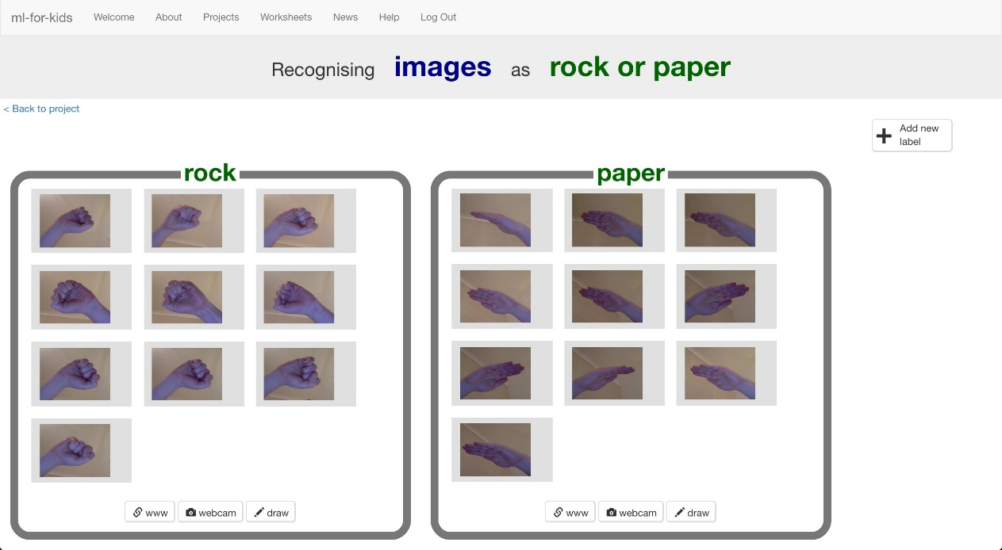

1. Click “**+ Add new label**” and create one called “scissors”

点击“+Add new label”以创建一个名为“剪刀”的分栏

1. Use the “webcam” button in the “scissors” bucket to take 10 photos of your hand in a “scissors” shape (two fingers).

点击“剪刀”分栏中的“webcam”并再次拍摄十张“剪刀”形状的照片（双指V型）

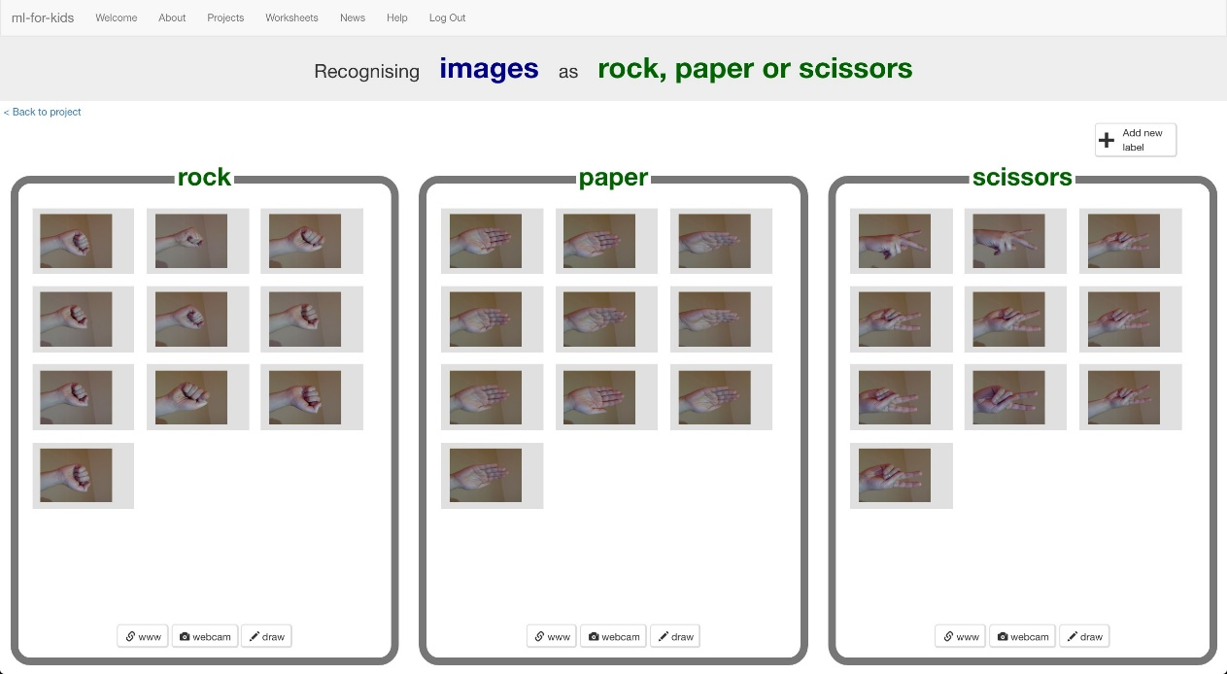

1. Click the “< Back to project” link.

点击“< Back to project”

1. Click the “Learn & Test” button.

点击“Learn & Test”

1. Click the “Train new machine learning model” button.

点击“Train new machine learning model”

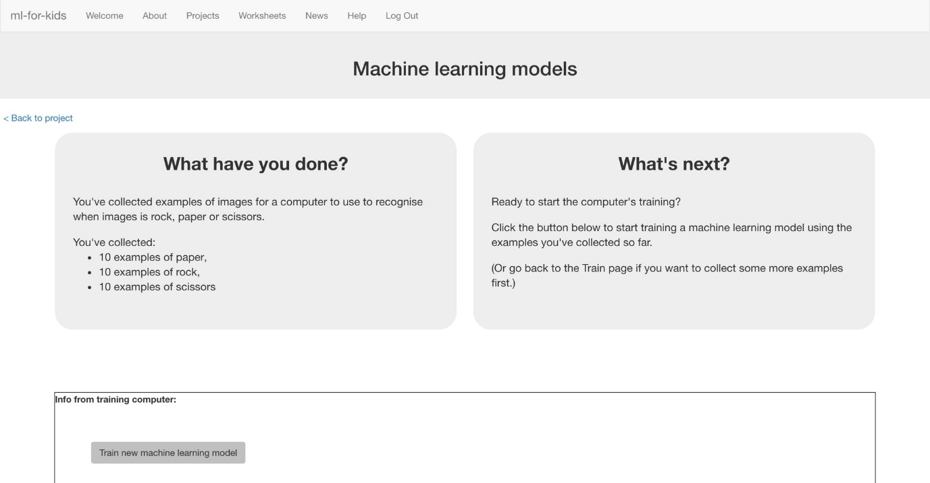

1. Wait for the training to complete. This might take a few minutes. While waiting, try to complete the machine-learning multi-choice quiz at the bottom of the page.

等待几分钟至训练完成，在等待的过程中尝试完成页面底部机器学习的多选测试

**What have you done so far?**

**到目前为止，你做了些什么？**

You’ve started to train a computer to recognise pictures as being rock, paper or scissors. You are doing it by collecting example photos. These examples are being used to train a machine learning “model”.

你已经开始训练电脑识别图片是石头、布还是剪刀。

你通过收集示例照片用来训练机器学习的“模型”来实现这一点

This is called “supervised learning” because of the way you are supervising the computer’s training.

因为你正在监督计算机训练的过程，所以这被称之为“有监督学习”

The computer will learn from patterns in the colours and shapes from each of the photos you’ve given it. These will be used to be able to recognise new photos.

**Tips 小技巧**

**Try and be even**

**尝试公平**

Try and come up with roughly the same number of examples for each shape.

**试着为每个形状提供大致相同数量的样本。**

If you have a lot of examples for one type, and not the other, the computer might learn that type is more likely, so you’ll affect the way that it learns to recognise photos.

如果你有很多关于一种类型的例子，而另一种类型的很少时，计算机训练时可能会认为更有可能是前种类型的图片，所以你会影响计算机学习图像识别的过程

**Mix things up with your examples**

Try to come up with lots of different types of examples.

**尝试得到不同类型的样本图片**

For example, you could include examples of your hand coming from the left side of the photo as well as examples of your hand coming from the right side.

举个例子，你可以用左右手来拍照同一类的照片

**If you’d rather use imgur.com than imagebin…**

use https://dalelane.github.io/webcam-to-imgur instead

**如果你更想使用imgur.com而非imagebin，**

**请使用**https://dalelane.github.io/webcam-to-imgur

**More examples!**

**更多训练样本！**

The more examples you give it, the better the computer should get at recognising whether a photo of your hand is rock, paper or scissors.

当你提供越多关于“石头、剪刀、布”的照片、能够使计算机更好地学习识别他们

1. Click the “Open in Scratch” button to launch the Scratch editor. You should see four new blocks in the “More blocks” section from your “rock paper scissors” project.

点击“Open in Scratch”以运行Scratch编辑器。你应该在“石头剪刀布”项目中的“More blocks”中看到新的区块



1. Open the Rock, Paper, Scissors project template.

打开“石头剪刀布”项目模板

*Click* ***Project templates*** *->* ***Rock, Paper, Scissors***

***点击“Project templates”再点击“石头剪刀布”***

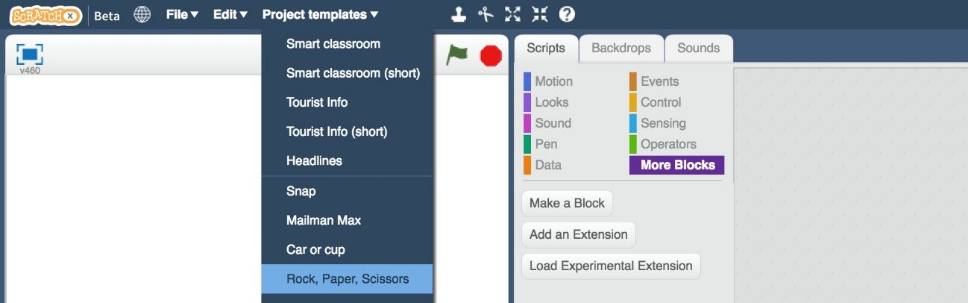

1. Click on the “**result**” sprite

点击“result”小图

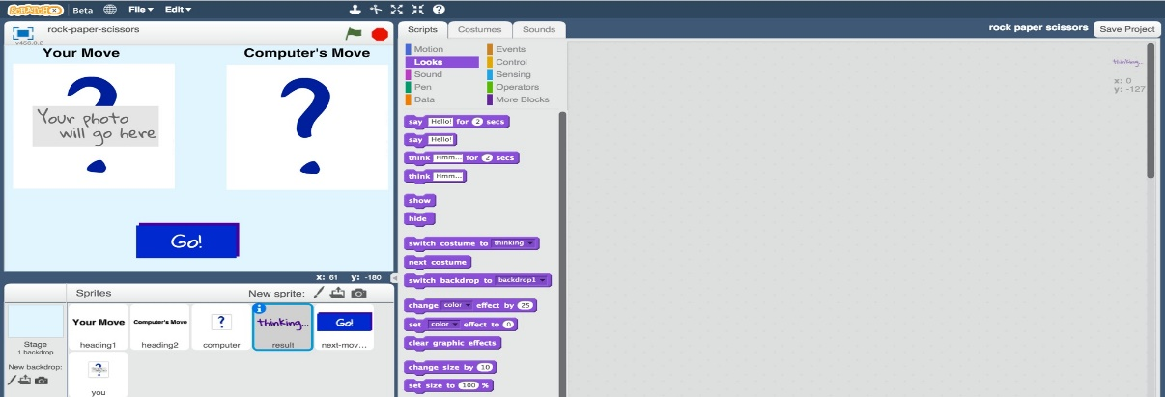

1. Add the following script blocks with the rules for the game to the “result” sprite.

将下图中的游戏规则脚本块加入到result中

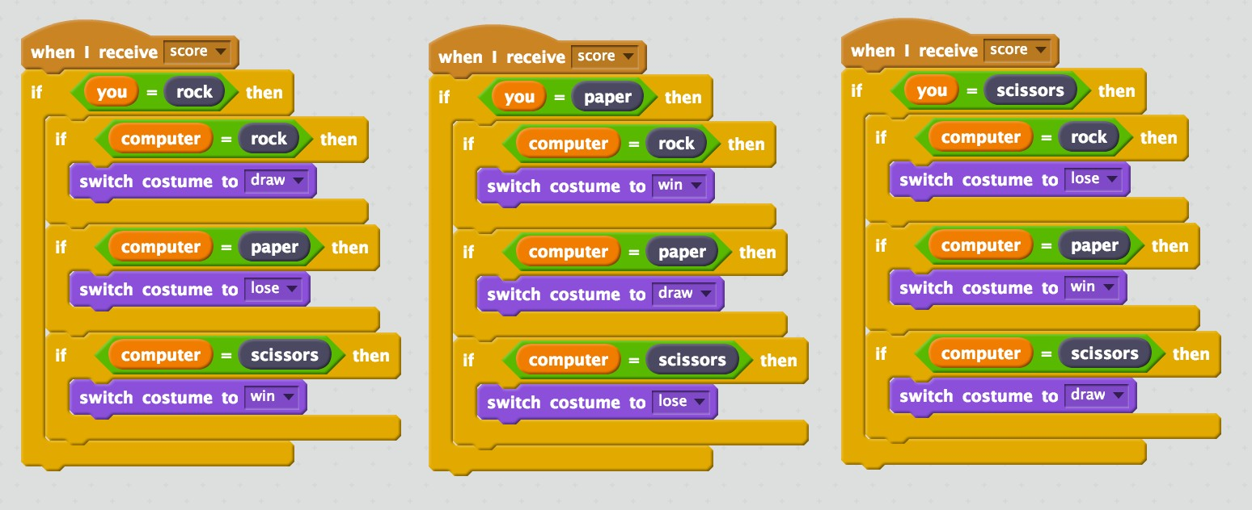

1. Click on the “you” sprite.

点击“you”小图

1. Click on the “costumes” tab.

点击“costumes”栏

1. Click the “New costume from camera” button

点击“New costume from camera”

*It’s the camera icon shown below.*

下图显示为摄像头图标

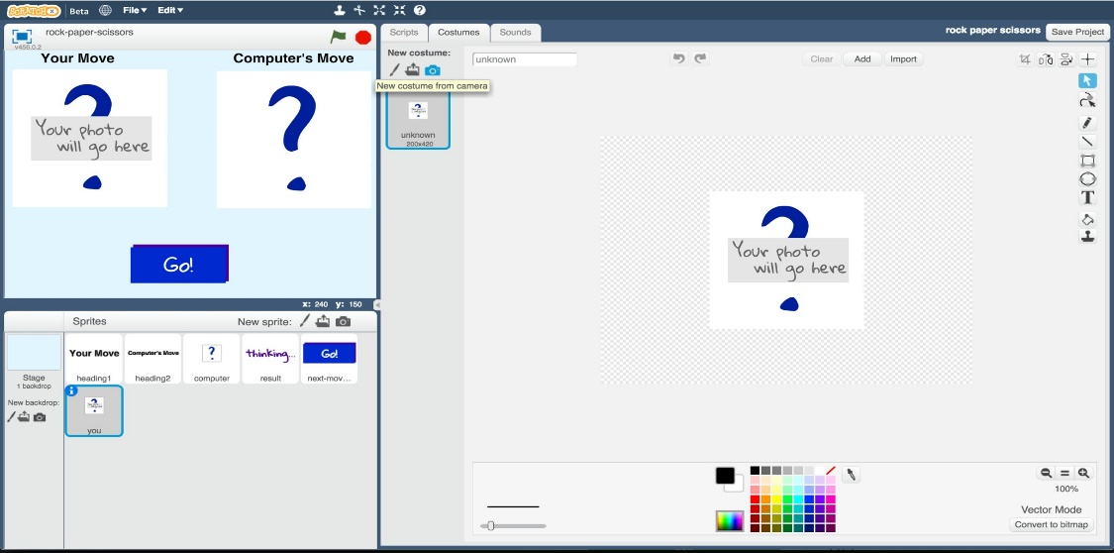

1. Take a photo of your hand

拍摄手部照片

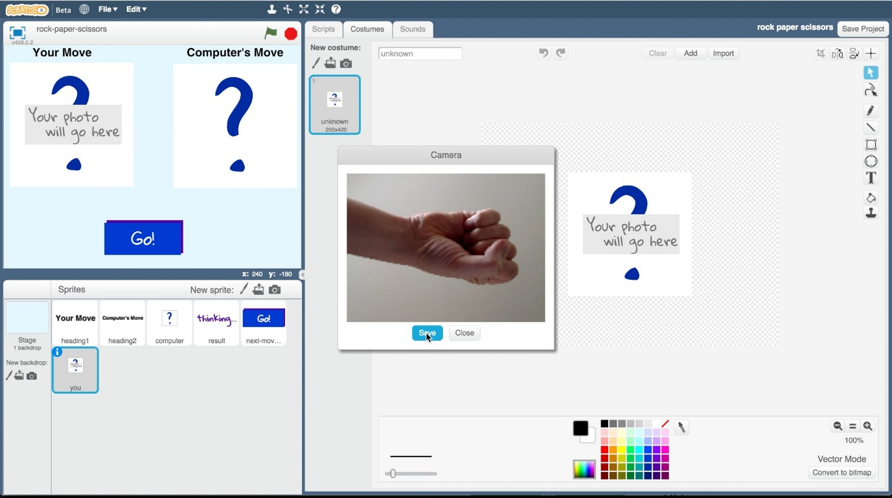

1. Click on the “**Scripts**” tab

点击“Scripts”栏

1. Add the following script blocks to the “you” sprite to let the computer recognise your move

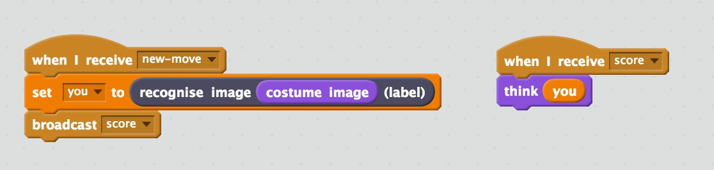

在“you”中加入下图中的脚本块使得计算机能够识别

1. Save your project.

保存项目

*Click* ***File*** *->* ***Save project***

点击“File”再点击“Save project”

1. Test your project

测试你的项目

Click the **Green Flag**, then click the “Go!” button in the game.

*The computer will choose a random picture for its side. It will try to recognise the shape of your hand, and then use the rules you entered to work out who won.*

点击“Green Flag”，再点击“Go!” 计算机将随机选择照片，尝试识别你的手部图片并根据规则判断谁获胜

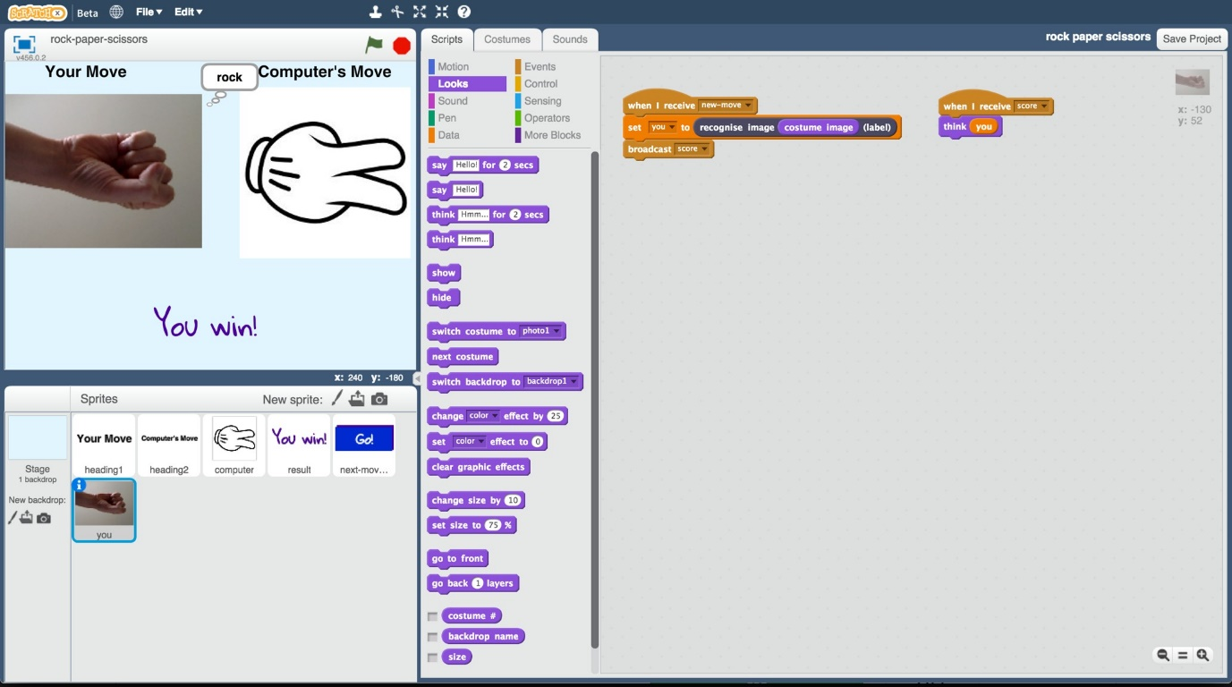

1. If the computer is not very good at recognising your hand shapes, go back to step 21, and add more examples for the computer to learn from. You’ll need to repeat step 24 and train a new machine learning model after you’ve added more examples.

如果计算机识别效果不佳，请参考第21步并添加更多的样本供计算机学习。加入后，你需要重复第24步训练新的模型

**What have you done?**

**你做了些什么？**

You’ve made a simple rock-paper-scissors game in Scratch.

你使用Scratch做了一个简易“石头剪子布”游戏

The game uses a webcam to take pictures of your hand, and uses machine learning to understand the meaning of the photo.

该游戏使用摄像头拍手部图并使用机器学习理解图片的含义

This is “image recognition” – teaching a computer to recognise images.